Day 3: Creating your first Android Application with Xamarin

Today, let’s go ahead and create our first Android Application with Android.

If you click on File-> New Project in Visual Studio after installing Xamarin, you should now see an Android option in your available templates.

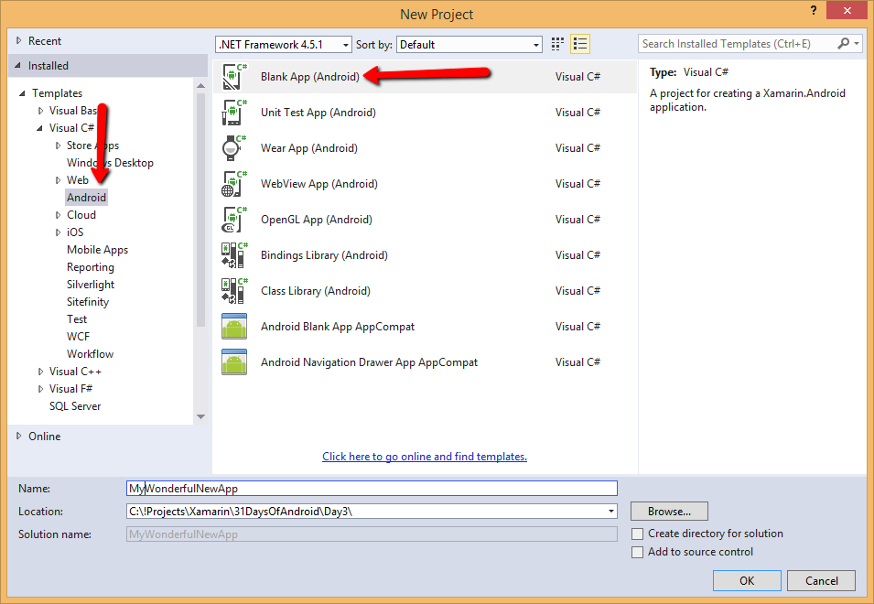

Go ahead and pick “Blank App (Android)” and click on OK.

Xamarin goes ahead and creates your first “Hello World” app.

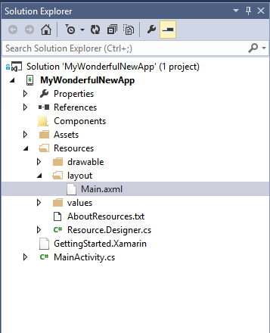

And if you were to just run the application (Make sure Xamarin Android Player with an emulator is running)

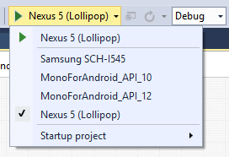

You will see your first Native Android Application up and running –

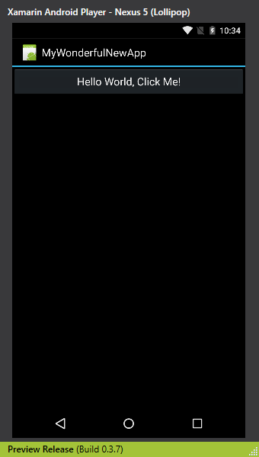

Go ahead and push the button and you will see button update its text as many number of times you pressed it.

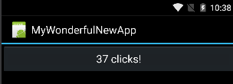

Voila, there you go. You just created an Android Application.

## One more thing…

But, let me show you something more: An easier way to get off the ground when creating Android Applications with Visual Studio. Xamarin’s evangelist [James Montemagno](https://twitter.com/JamesMontemagno) created a really awesome template pack Visual Studio which you can download [here](https://visualstudiogallery.msdn.microsoft.com/bee6442f-8f5a-4bba-8849-e380b61e76b0). And if you download the extension and install it you will see two new options appear in your Visual Studio Templates Options under Android –

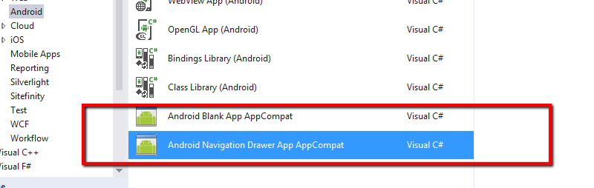

Let’s pick “Android Navigation Drawer App AppCompat” and let’s go ahead and create the project. Don’t worry about what and App Drawer is and what AppCompat is, we will get to what they are in the series in detail.

The project structure should feel very similar to our first app but the app has additional references to Xamarin’s Android Support Design Libraries.

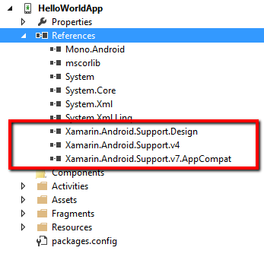

And if you were to just run the app in an emulator, you see a really polished starting point for your application.

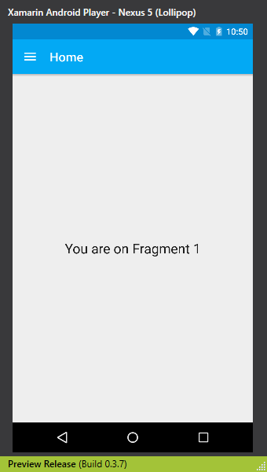

And if you press the little hamburger menu item (the three bars on the left) you will see the App Drawer come out –

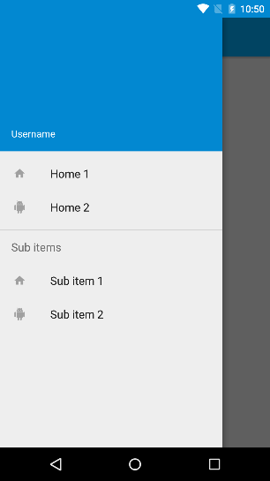

That’s it for today. Tomorrow, we will explore Android Apps Project File Structure.

Venkata